**NUR SHAFWANI BINTI SAMEON** 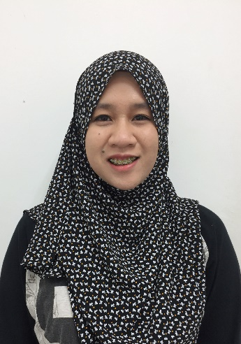

**PERSONAL INFORMATION**

Date of Birth : 6th December 1992

Address : No.10,Jalan PU 9/6B,

Taman Puchong Utama, 47100,Puchong, Selangor.

H/P number : +6014-2301871

Email Address : [nurshafwani1026@gmail.com](mailto:nurshafwani1026@gmail.com)

Nationality : Malaysian

Hobbies : Travelling, Reading and Explore New Things.

**EDUCATION**

* **BACHELOR** (2014-2016)
* In Engineering Technology (Electrical & Electronic) Hons.
* Management & Science University (MSU)
* Current CGPA = 2.29
* **DIPLOMA** (2010-2013)
* In Electrical & Electronic Engineering
* Management & Science University (MSU)
* CGPA = 2.89
* **SPM** (2009)
* Electrical & Electronic Engineering Studies
* Sekolah Menengah Teknik Kuala Lumpur.

**LANGUAGES**

|  |  |  |
| --- | --- | --- |
| Language | Written | Spoken |
| Bahasa Malaysia | 10 | 10 |
| English | 9 | 8 |

*(Best = 10 – Worst = 1)

**WORK EXPERIENCES**

* **PRACTICAL**

Company Name: Globetronics Sdn. Bhd.

Position : Technician

Duration : 3 months (November 2012 -- February 2013)

* **PART TIME**

Company Name: AEON Jusco IOI Mall.

Position : Promoter

Duration : 6 months (2009)

**SKILLS**

* Microsoft Office Word
* Microsoft Power Point
* Microsoft Excel
* MATLAB
* PCB wizard
* SolidWorks
* Circuit Wizard

**INTERPERSONAL**

* Work well under pressure
* Good team player
* Interact well with people
* Adaptive to new environment
* Fast learning